User Management

What is Umask?
- Umask stands for User Mask or User file creation Mask.
- It is the defaults permission or base permission given when a user creates new file or even folder (as Linux treats everything as file.)
- Most of the Linux distribute give Umask as defaults permissions (0022) for root user and (0002) for normal users. In other words, it is a system defaults permission for newly created files/folders in the machines.

How to calculate Umask in Linux?
One thing is umask value is generally the same for files and directories but the calculation of these values based on the permissions on files and directories are different.

Minimum UMASK value for directory: 000 and Maximum: 777
Minimum UMASK value for file: 000 and Maximum: 666

Why 666 is the maximum value for a file?
This is because only scripts and binaries should have executed permissions, normal and regular files should have just read and write permissions. Directories require execute permissions for viewing the contents in it, so they can have 777 as permissions.

How to set or change default UMASK for all the new users?
The UMASK value can be set in /etc/profile for all the new users. Open this file as root user and write below line in the file.
# umask 027

How to set or change default UMASK for existing users?
For existing users, you can edit ~/. bashrc file in their home directory. This should be done for all the users one by one or if a machine is having a lot of users, then you have to write a shell script for this.

I see people are using 0022 and 022 as UMASK, is there any difference between them?
There is no difference between these two, both indicates one and the same. The preceding 0 indicates there is no SUID/SGID/Sticky bit information set.

What is the preferred UMASK value for a system for Security reasons?
Preferred is 027 (0027) for security reasons because this will restrict others not to read/write/execute that file/folder

Explain file permission in Linux?
In Linux, there are 3 main types of file permissions: read, write and execute. These permissions can be assigned to either a file or a directory recursively. Being a multi-user system, you can assign these permissions to the root user, groups or even to other users using the system.
- Read: The read permission grants uses the ability to open and read a file.
- Write: write permission allows users to open and modify or edit the file’s contents and save the changes.
- Execute: This allows a user to execute or run the file or a program or shell which is executable.
Please find below Linux permission table:
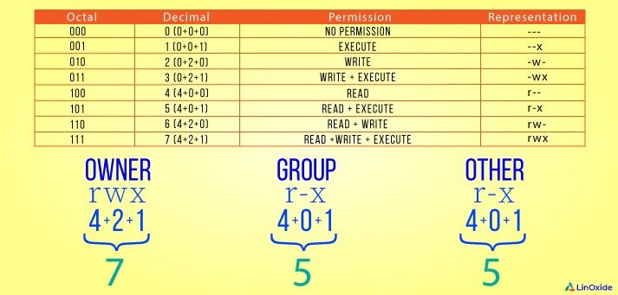
Special permissions (SUID, SGID and Sticky bit)

What is Set User ID (Setuid)?
- It is a special permission assigned to a file. If the permission is set on file, then that file always run with the privileges of the owner of the file. No matter who runs this execution.
- For example, if a file was owned by the root user and has the setuid bit set, no matter who executed the file it would always run with the root user privileges.

How to set SUID bit on a file?
You must be the owner of the file or the root user to set the setuid bit. Run the following command to set the setuid bit:
# chmod u+s file1
View the permissions using the ls -l command:
# ls -l file1
-rwSrw-r-- 1 user1 user1 0 2017-10-29 21:41 file1

Note the capital S. This means there are no execute permissions. Run the following command to add execute permissions to the file1 file, noting the lower-case s.
# chmod u+x file1
# ls -l file1
-rwsrw-r-- 1 user1 user1 0 2017-10-29 21:41 file1
Note: the lower cases. This means there are execute permissions.
Alternatively, you can set the setuid bit using the numeric method by prepending a 4 to the mode. For example, to set the setuid bit, read, write, and execute permissions for the owner of the file1 file, run the following command:
# chmod 4700 file1

What is Set Group ID (setgid) for files?
- When the SUID bit is set, the executable is run with the authority of the group.
- For example, if a file or directory owned by the user’s group, no matter who executed that file it would always run with the authority of the user’s group.

How to set the SGID bit for files?
Run the following command to set the setgid bit on file1.
# chmod g+s
Note: Both the setuid and setgid bits are set using the s symbol. The setgid is represented the same as the setuid bit, except in the group section of the permissions.
Run the following command as root to set the setgid bit, and read, write, and execute permissions for the owner of the file1 file:
# chmod 2700 file1
The setgid is represented the same as the setuid bit, except in the group section of the permissions:
ls -l file1
-rwx--S--- 1 user1 user1 0 2017-10-30 21:40 file1
Use the chmod u+s command to set the setuid bit. Use the chmod g+s command to set the setgid bit.

What is Set Group ID permissions for directories?
- When the setgid bit is set on a directory, all files created within said directory inherit the group ownership of that directory.
- For example, the folder1 folder is owned by the user user1, and the group group1:

# ls -ld folder1
drwxrwxr-x 2 user1 group1 4096 2017-10-30 22:25 folder1
Files created in the folder1 folder will inherit the group1 group membership:
# touch folder1/file1
# ls -l folder1/file1
-rw-rw-r-- 1 user1 group1 0 2017-10-30 22:29 folder1/file1

How to set the SGID bit for directories?
To set the setgid bit on a directory, use the chmod g+s command:
# chmod g+s folder1
View the permissions using the ls -ld command, noting the s in the group permissions:
# ls -ld folder1
drwxrwsr-x 2 user1 group1 4096 2017-10-30 22:32 folder1
Alternatively, prepend a 2 to the directory’s mode:
# chmod 2770 folder1

What is a sticky bit in a directory?
When the sticky bit is set on a directory, only the root user, the owner of the directory, and the owner of a file can remove files within said directory.

How to set Sticky bit?
An example of the sticky bit is the /tmp directory. Use the ls -ld /tmp command to view the permissions:
# ls -ld /tmp
drwxrwxrwt 24 root root 4096 2017-10-30 22:00 tmp
The t at the end symbolizes that the sticky bit is set. A file created in the /tmp directory can only be removed by its owner, or the root user. For example, run the following command to set the sticky bit on the folder1 folder:
# chmod a+t folder1
Alternatively, prepend a 1 to the mode of a directory to set the sticky bit:
# chmod 1777 folder1
The permissions should be read, write, and execute for the owner, group, and everyone else, on directories that have the sticky bit set. This allows anyone to cd into the directory and create files.

How to find files with SUID/SGID bit set?
- To find all the files with SUID bit set, use the below command:
# find / -perm +4000

- To find all the files with SGID bit set, use the below command:
# find / -perm +2000
You can also combine both the commands to find both SGID and SUID but set files.
# find / -type f \\ (-perm -4000 -o -perm -2000 \\) -exec ls -l {} \\;

User Management by commands
https://www.tecmint.com/manage-users-and-groups-in-linux/

